**Jesus loves me and forgives me**

**Reading:** Luke 15:20-24

When the son was still a long way off, his father saw him coming and felt sorry for him. So he ran to him and hugged and kissed him. The son said, ‘Father, I have sinned against God and done wrong to you. I am no longer worthy to be called your son.

But the father said to his servants, ‘Hurry! Bring the best clothes and put them on him. And, also put a ring on his finger and good sandals on his feet. And bring our best calf and kill it so that we can celebrate with plenty to eat. My son was dead, but now he is alive again! He was lost, but now he is found!’ So they began to have a party.

**Thought about the reading**

This is a story Jesus told to show us how much God the Father loves us. In the story the son took the money that his father gave him, and he went away. He wasted all the money till he had nothing left. He got a job looking after pigs, but he was still hungry. He realised that his father’s servants had better food than he did. He decided to go home, tell his father he was sorry.

But his father must have been watching! He saw him coming and he ran to him! He was so happy to see him again! He gave him new clothes and shoes and threw a big party to celebrate his return.

Sometimes, we are like the son. We turn away from God and waste the good things he has given us. But when we turn back to him to say sorry, he is waiting for us. He forgives us, just as the father forgave the son in the story. God is very happy when we tell him we are sorry. He is so happy, maybe he has a party in heaven with the angels!

**Prayer**

Father God, thank you that you love me.

I am sorry for all the wrong things I have done. Please forgive me.

Amen

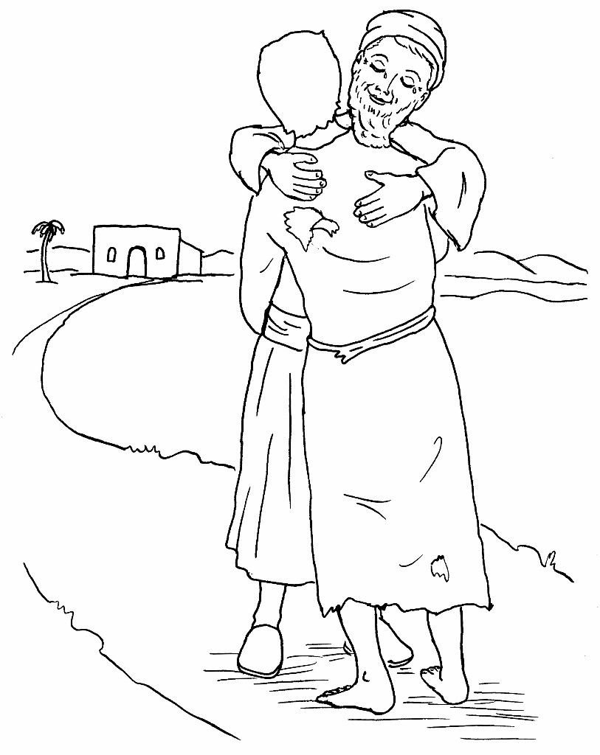

**Cambridge Causeway**

Autumn 2021

Bible Study notes

Jesus loves me and forgives me

By Chrissy Cole